Assignment – 01

# Name – Md. Farhan Ishmam

# Student ID – 180041120

# Department – Computer Science and Engineering

# Course Number - EEE 4484

# **Experiment – 01**

# Task – 01

The data reading table is given below:

|  |  |  |
| --- | --- | --- |
| DC Voltage Source (V) | Diode Voltage (V) | Diode Current (mA) |
| 0.1 | 0.099 | 1.01*10^-5 |
| 0.15 | 0.14998 | 1.52*10^-5 |
| 0.2 | 0.1998 | 2.01*10^-5 |
| 0.25 | 0.24997 | 2.55*10^-5 |
| 0.3 | 0.29997 | 3.01*10^-5 |
| 0.4 | 0.39996 | 4.02*10^-5 |
| 0.5 | 0.49995 | 5.01*10^-5 |
| 0.6 | 0.59994 | 6.01*10^-5 |
| 0.65 | 0.64993 | 6.51*10^-5 |
| 0.675 | 0.67493 | 6.76*10^-5 |
| 0.7 | 0.69993 | 7.02*10^-5 |
| 0.8 | 0.7 | 0.1 |
| 1 | 1 | 0.3 |
| 2 | 2 | 1.3 |
| 3 | 3 | 2.3 |

The screenshot of the circuit done in PSIM is given below:

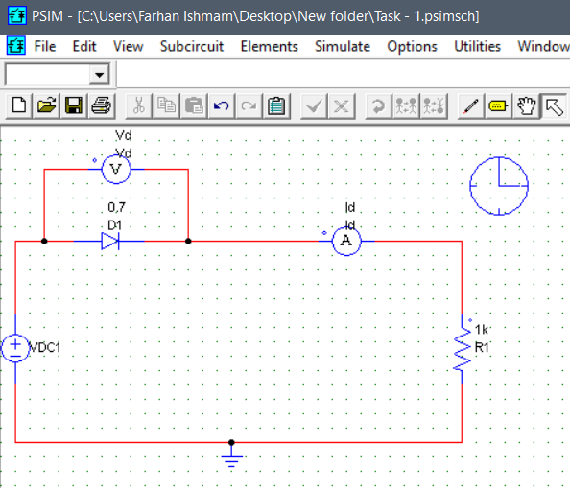

The linear V-I hand-drawn curve is given below:

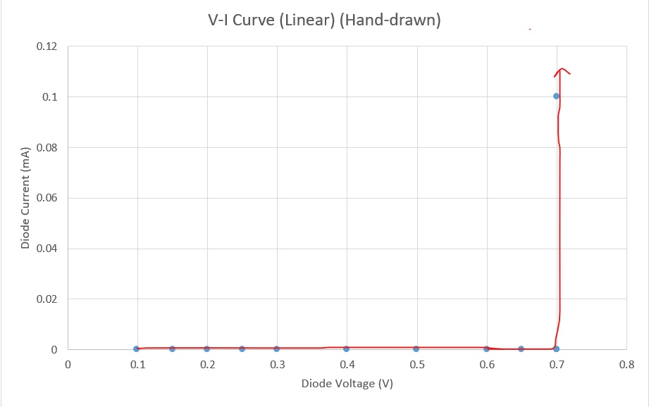

We have taken the hand-drawn version of the graph as the computer generated version is more linear. To have a better understanding of the curve I have also shown the logarithmic version below:

# Task -2

As per instruction in the lab, ideal diode has been taken. The circuit constructed in PSIM is given below:

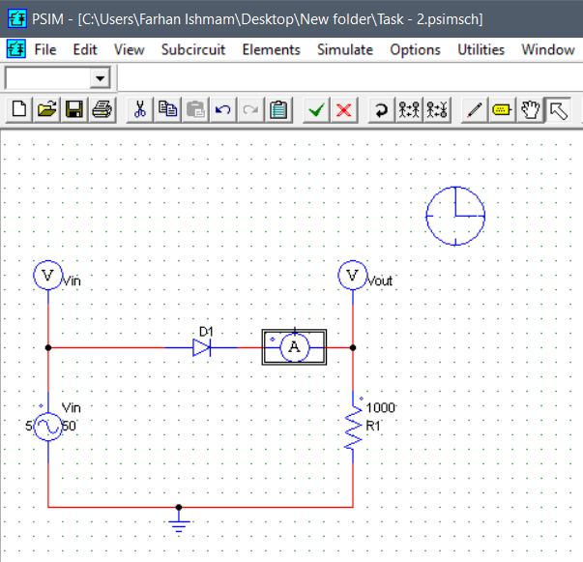

The Input Voltage graph as simulated by PSIM is given below:

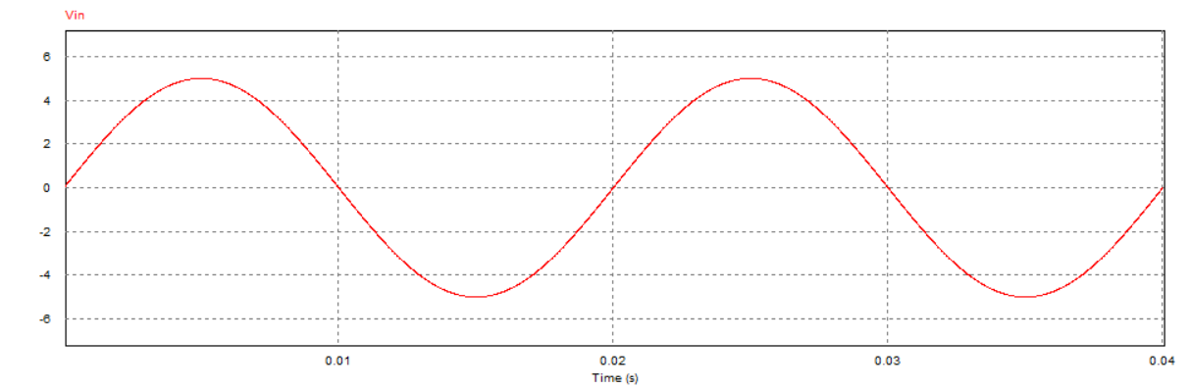

The Output Voltage graph as simulated by PSIM is given below:

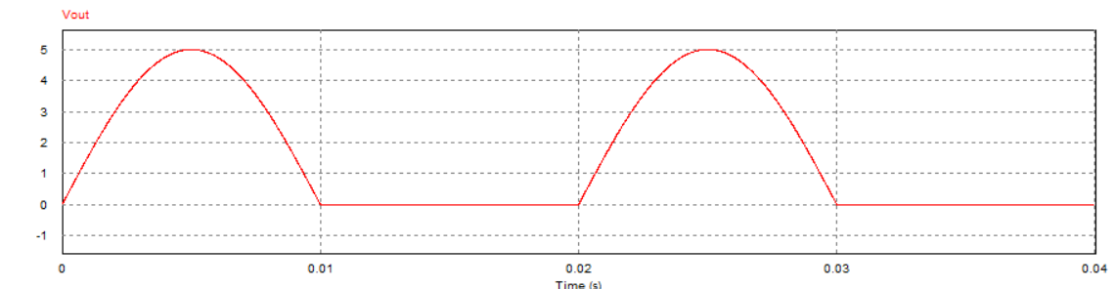

The Input and Output Voltage graph as simulated by PSIM is given below:

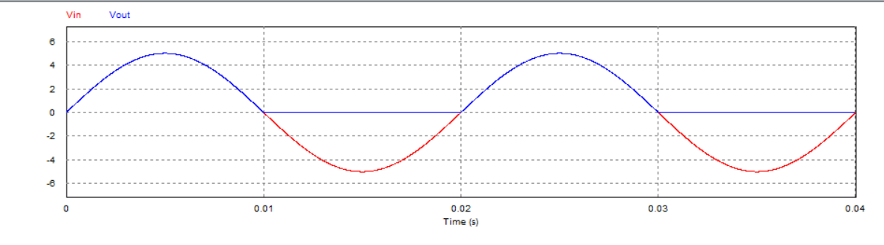

The graph of the current flowing through our circuit is given below:

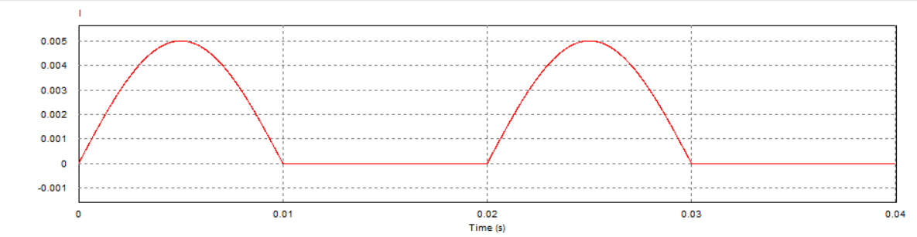

# Task -3

The given circuit taking ideal diodes constructed in PSIM is given below:

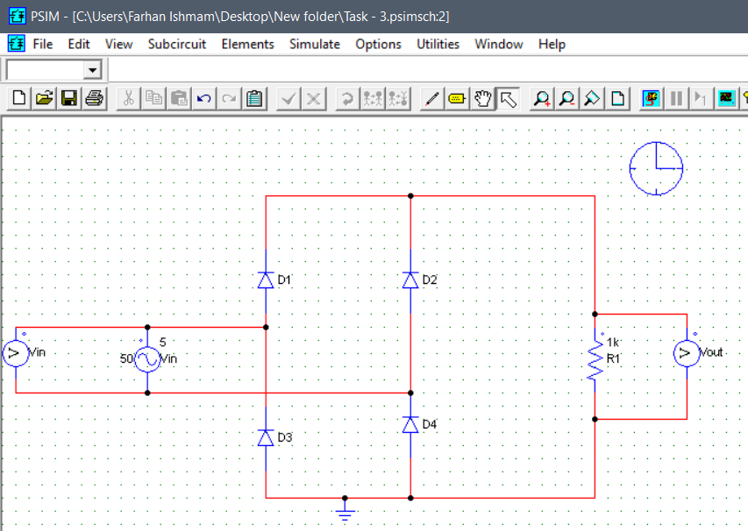

The Input Voltage graph as simulated by PSIM is given below:

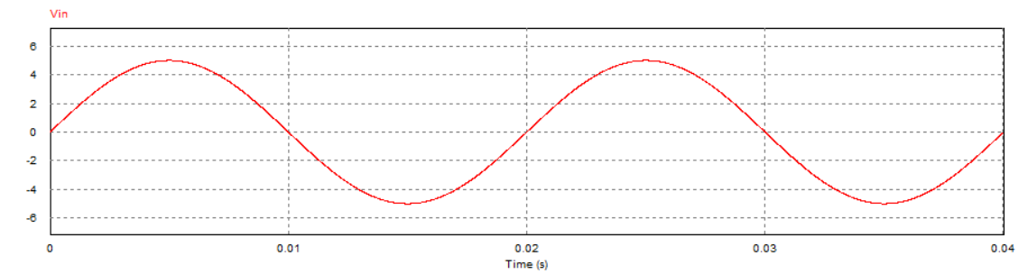

The Output Voltage graph as simulated by PSIM is given below:

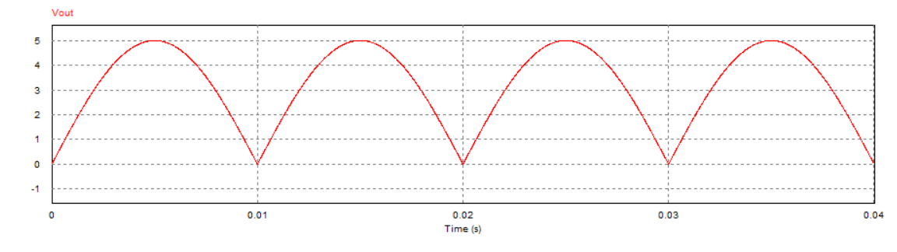

The Input and Output Voltage graph as simulated by PSIM is given below:

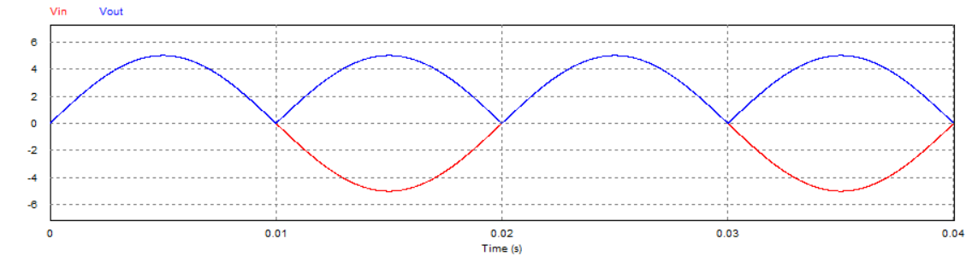

**Assignment**

# Assignment – 02

The value of Vi is taken as 10V to show that graph above 5V is getting clipped.

The given circuit is constructed in PSIM as shown below:

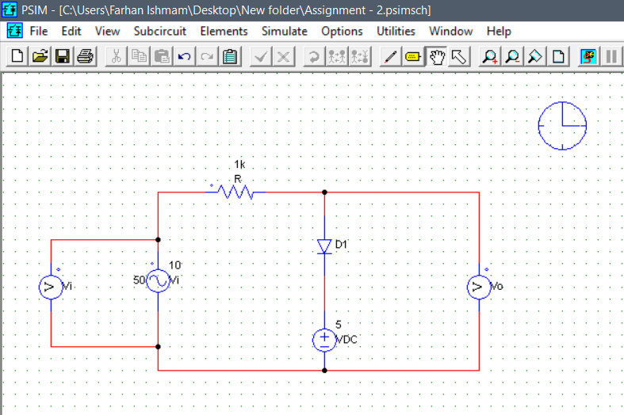

The Input Voltage graph is given below:

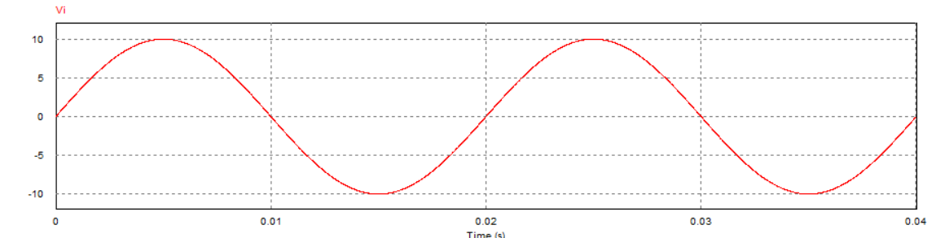

The Output Voltage graph is given below:

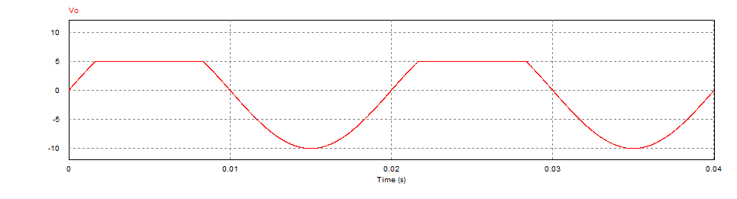

# Assignment – 03

The required circuit is constructed in PSIM and shown below:

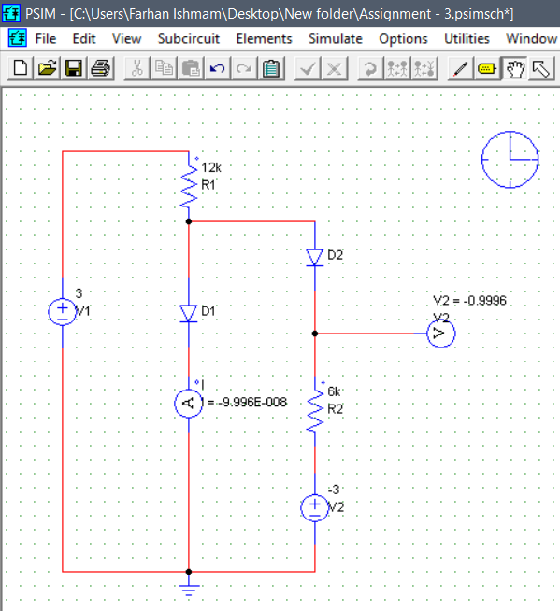

The value of **I is -9.996 E-08 Ampere** and the value of **V is -0.9996 Volt.**

Let, D1 and D2 be in forward bias. We can easily find current flowing though R1 and R2.

Current flowing through R1, I1 = (3 – 0)/12000 = 0.25 mA

Current flowing through R2, I2 = (0 – (-3))/6000 = 0.5 mA

So, current flowing through D1, I = (I1 – I2) = (0.25 – 0.5) = -0.25 mA

This means that current is flowing through opposite direction in D1 and thus our assumption of D1 being in forward bias is wrong. Hence, D1 is in reverse bias. It is to be noted that the diodes are short-circuited in forward bias and have infinite resistance in reverse bias since we are using ideal diodes.

Now, taking D1 in reverse bias and D2 in forward bias, we get,

The current passing through D1, **I = 0 mA** (Since, the diode before has infinite resistance)

We know, the voltage across R2 = V – (-3)

* I2 * R2 = V – (-3)

As D1 is short circuited, the value of I2 is

I2 = (3 – (-3)) / (12000 + 6000) = 1/3 mA

So, putting the value of I2, we get,

(1/3)*10^-3*6000 = V – (-3)

* V = (1/3)*6 + (-3)
* V = 2-3
* V = -1

So, the value of **V = -1 V**.

Our calculated values matches with the values we found from PSIM.

# Assignment – 04

The circuit constructed in PSIM is shown below:

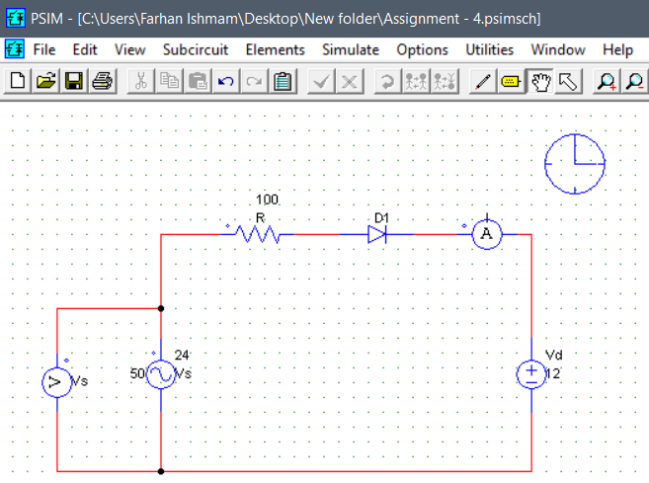

The Voltage graph is given below:

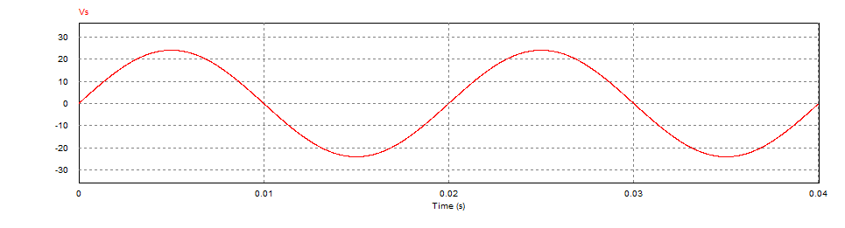

The current graph is given below:

